**Measuring Distance using ULTASONIC Sensor**

**Description**: In this project, we will measure the of any object using Ultrasonic Sensor.

**Hardware Requirement:**

* Arduino Uno board
* Ultrasonic Sensor
* Jumper wire
* Breadboard

**Ultasonic sensor:**

It is a sensor which generate Ultra Sound(almost 40000Hz) from the Trig pin of the Ultrasonic Sensor. And a receiver (Echo pin) of the ultrasonic sensor.

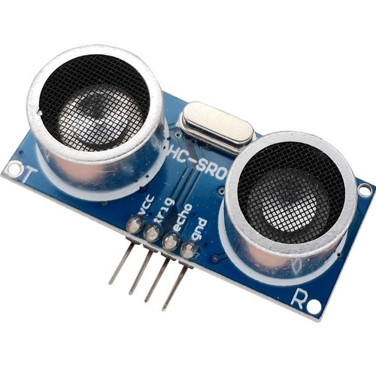

**Specifications:**

|  |  |
| --- | --- |
| Operating Voltage | DC 5V |
| Operating Current | 15mA |
| Operating Frequency | 40KHz |
| Max Range | 4m |
| Min Range | 2cm |
| Ranging Accuracy | 3mm |
| Measuring Angle | 15 degree |
| Trigger Input Signal | 10µS TTL pulse |
| Dimension | 45 x 20 x 15mm |

**Connection**:

* VCC pin connected to Arduino’s 5V pin
* Trig pin connected to Arduino’s pin-2
* Echo pin connected to Arduino’s pin-4
* GND pin connected to Arduino’s GND pin

**Process :**

1. Trig pin HIGH for 10 micro seconds and it will generate a ultrasound
2. Echo pin receives the ultrasound after a time period
3. Calculate the Time period
4. This time period gives us Microseconds Value
5. And then we multiply time period with the 0.034m/microseconds

**Circuit Diagram:**

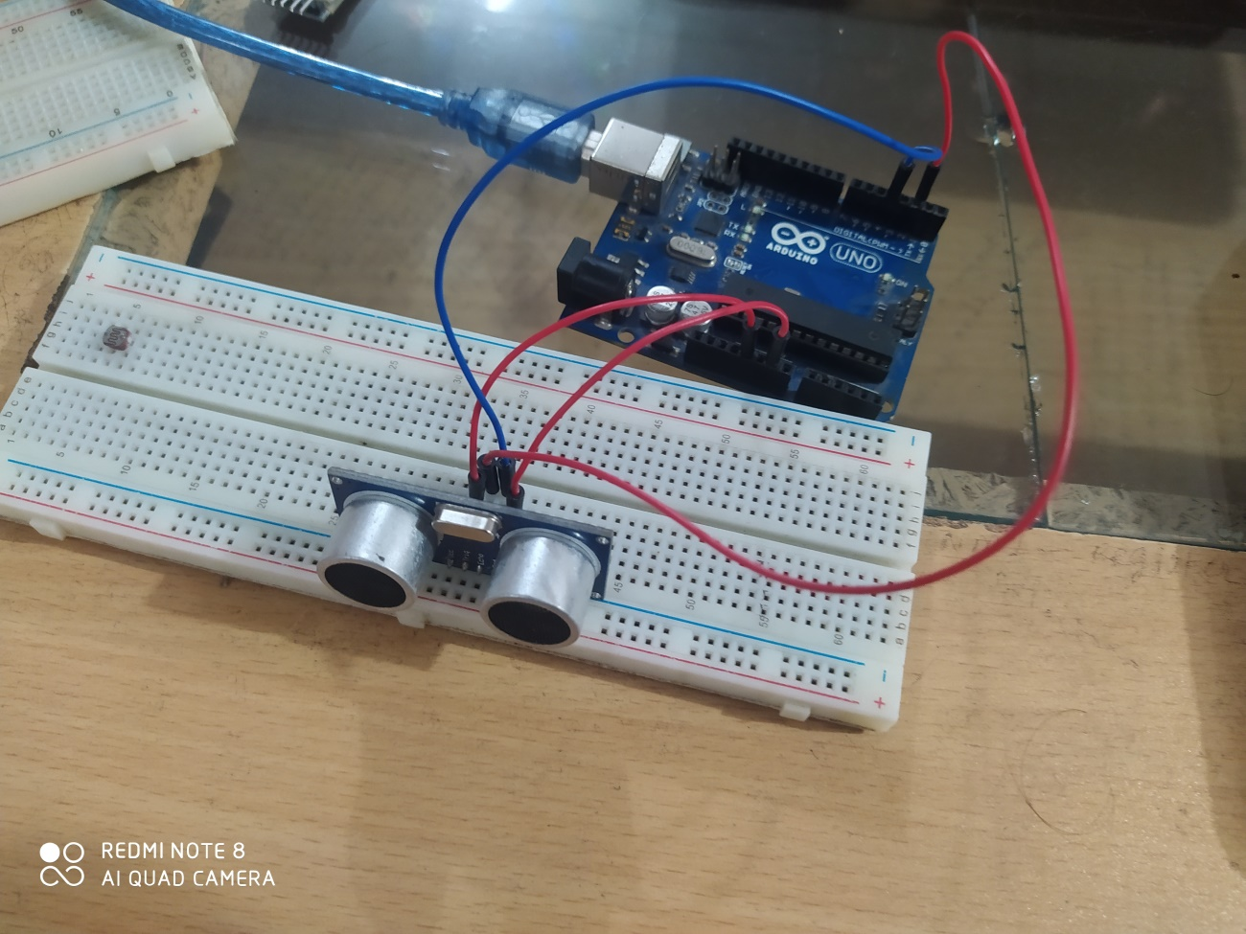

Code:

|  |  |
| --- | --- |
| |  | | --- | | int trigpin=2; int echopin=4; int duration; int distance;  void setup() {   // put your setup code here, to run once: pinMode(trigpin,OUTPUT); pinMode(echopin,INPUT); Serial.begin(9600); }  void loop() {   // put your main code here, to run repeatedly: digitalWrite(trigpin,LOW); delay(2); digitalWrite(trigpin,HIGH); delayMicroseconds(100); digitalWrite(trigpin,LOW); duration=pulseIn(echopin,HIGH); distance=(duration*0.034)/2; Serial.print("Distance : "); Serial.print(distance); Serial.println("cm"); delay(500); } | |

Vedio link:

<https://www.youtube.com/watch?v=5MG64i0HBg4&list=PL7euiE97qGc0QbibUmHn5MBrF2V7w3NDa&index=22>